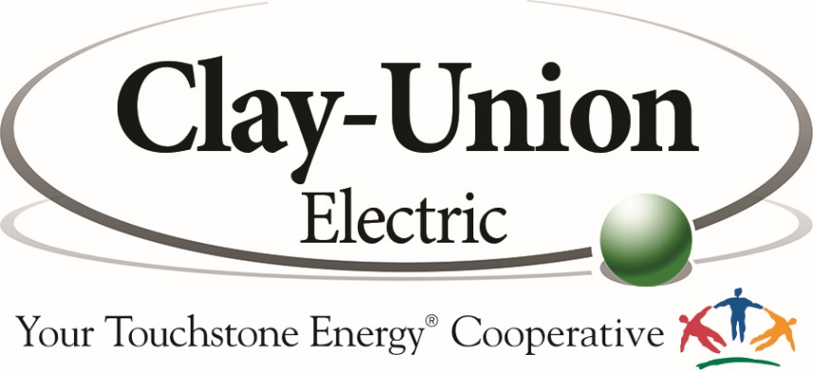

ELECTRICIAN FOREMAN
Clay-Union Electric Corporation, located in Vermillion, SD is accepting applications for an Electrician Foreman. This is a full-time regular position.
Clay-Union Electric Corporation is a distribution cooperative that provides power through a 1200-mile distribution system to 2700 member/owners throughout most of Clay and Union counties.
Minimum requirements: High school graduate. Graduate of post-secondary Education is preferred. Experience with personal computers and Microsoft Office products is required. Ability to obtain a Class A commercial driver’s license and possess a South Dakota electrical contractors license is required.
Clay-Union offers a competitive salary based on qualifications. We also offer an excellent benefit package which includes health insurance, a defined benefit pension and 401k contribution.
To apply for this position, visit www.clayunionelectric.coop to download an application. Please submit the application, letter of interest and three references to mkruse@clayunionelectric.coop. Questions can be directed to Mike at the email address or 605-624-2673.
Applications will be accepted until March 21, 2023.

Clay-Union Electric is an Equal Opportunity Provider and Employer

