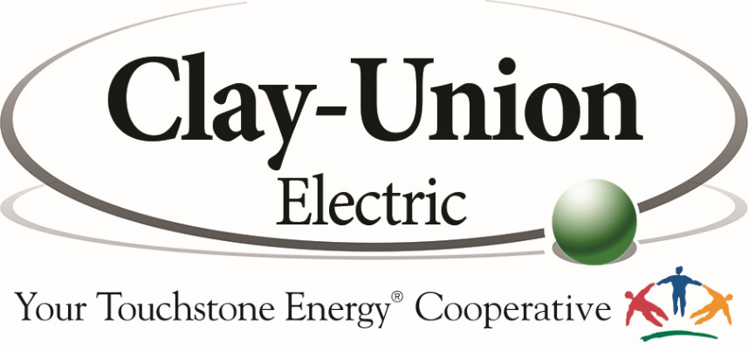

Lineworker
Clay-Union Electric Corporation, located in Vermillion, SD is accepting applications for a Lineworker. This is a full-time regular position. Preference will be given to an individual that has successfully completed a four-year accredited journey lineworker training program. The successful candidate must have a current Class A CDL driver’s license with a good driving record.
Clay-Union Electric Corporation is a distribution cooperative that provides power through a 1200-mile distribution system to 2700 member/owners throughout most of Clay and Union counties.
Clay-Union offers a competitive salary based on qualifications. We also offer an excellent benefit package which includes health insurance, a defined benefit pension and 401k contribution.
To apply for this position, visit www.clayunionelectric.coop to download an application. Please submit the application, letter of interest and three references to mkruse@clayunionelectric.coop. Questions can be directed to Mike at the email address or 605-624-2673.
Applications will be accepted until the position is filled.

Clay-Union Electric is an Equal Opportunity Provider and Employer

